DNA Function, Structure and Replication

DNA Function, part 1
1. Everyone has heard of DNA, but what is it and what does it do? Briefly summarize what you already know about DNA.

A key fact about DNA is that each DNA molecule contains many genes. A gene is a segment of DNA that provides the instructions for making a protein.

A cell needs many different types of proteins to function. For example, a cell needs:
- protein enzymes to carry out the chemical reactions that sustain life
- transport proteins to move ions and molecules into and out of the cell.

2. All organisms, including humans, other animals, plants, bacteria and other prokaryotes, have DNA inside their cells. Why does each type of cell need to have DNA?

Genes influence an organism's characteristics by determining what types of proteins the organism makes. The table below shows the effects of two different versions of a human gene.

Gene in DNA | → | Protein | → | Characteristic
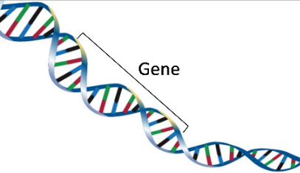 | → | 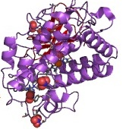 | → | 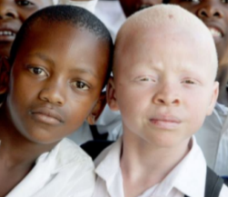
One version of the gene gives the instructions for making a functional protein enzyme. | → | The functional enzyme makes melanin, the pigment molecule in skin and hair. | → | Normal skin and hair color
Another version of this gene gives the instructions for making a nonfunctional version of this protein. | → | The nonfunctional protein does not make melanin. | → | Very pale skin and hair = albinism

3. Explain how a difference in their DNA can result in one boy being albino and the other boy having normal skin and hair color. (A complete answer will include the words: gene, protein, enzyme, and melanin.)

DNA Structure
Understanding the structure of DNA will help you to understand how DNA gives the instructions for making proteins. A DNA molecule has two strands of nucleotides twisted together in a long spiral called a double helix. This figure shows a small part of a double helix and the chemical structure of a short segment of this double helix.
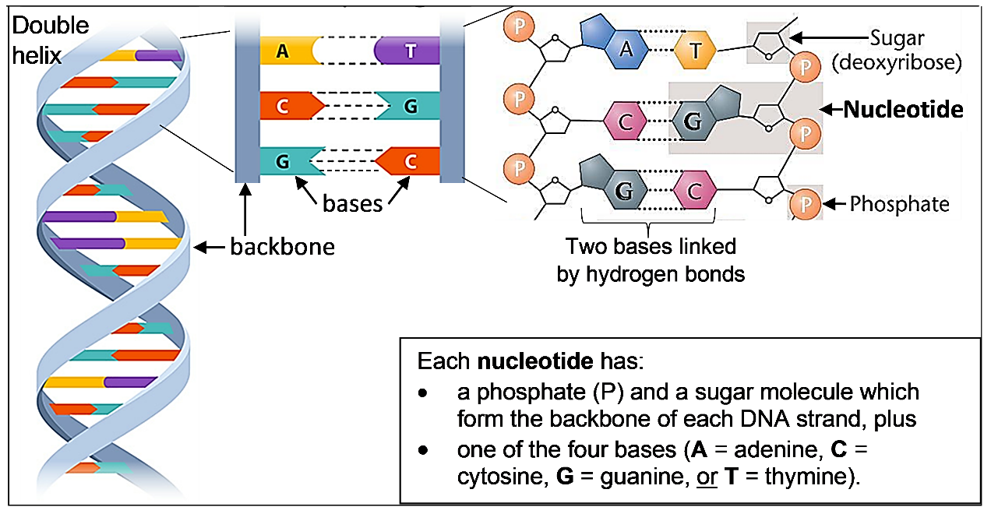
4. For the DNA strand on the right, draw a rectangle around the top nucleotide. Circle the base in that nucleotide.

5. Each base in one strand of the DNA double helix is paired with a base in the other strand. The base-pairing rules describe which bases pair together in a DNA double helix.
A in one strand pairs with _____ in the other strand.
C in one strand pairs with _____ in the other strand.

6. The only difference between DNA nucleotides is the base each nucleotide contains. Therefore, a nucleotide is given the same symbol as the base it contains (A, C, G, or T) and the base-pairing rules apply to the nucleotides. The nucleotides that pair together are called complementary nucleotides. Which nucleotide is complementary to G?

7. The sugar of each nucleotide is bound to the phosphate of the next nucleotide to make the backbone of each DNA strand. Use a dashed line to draw a rectangle around the backbone of the DNA strand on the right in the top figure on this page.

8. In the double helix diagram, the backbone of each strand is shown as a helical ribbon. What
is represented by each horizontal bar in the double helix diagram?

A typical DNA molecule contains millions of nucleotides, so DNA is a very long thin molecule. Proteins help to organize this long thin molecule in the small space of the nucleus. The combination of a DNA molecule and the associated proteins is called a chromosome. Each human cell has 46 chromosomes, and each human chromosome has hundreds or thousands of genes.
DNA Function, part 2
Different versions of a gene have a different sequence of nucleotides. As shown in the figure below:
the sequence of nucleotides in the DNA of a gene
determines the sequence of nucleotides in RNA which
determines the sequence of amino acids in a protein which
determines the structure and function of the protein which
influences the characteristics of the organism.

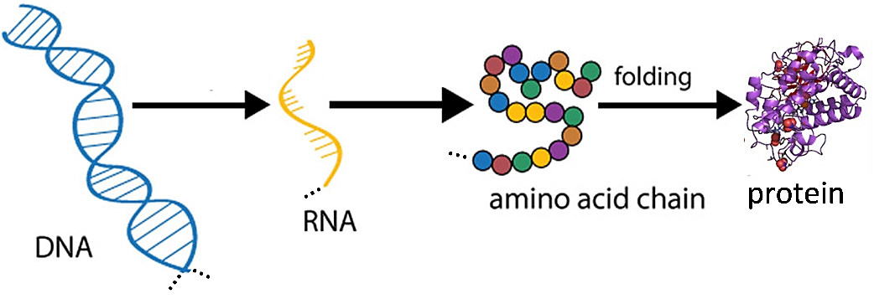

9. Explain how a difference in the sequence of nucleotides in a gene can result in one boy being albino and another boy having normal skin and hair color. (Hints: See the bottom half of page 1. A complete answer will include these terms: nucleotides, sequence, amino acids, protein, enzyme, and melanin.)

DNA Replication
Our bodies need to make new cells to grow and to replace damaged cells. This figure shows how new cells are formed by cell division. Before a cell divides into two daughter cells, the cell makes a copy of all of its DNA (DNA replication).

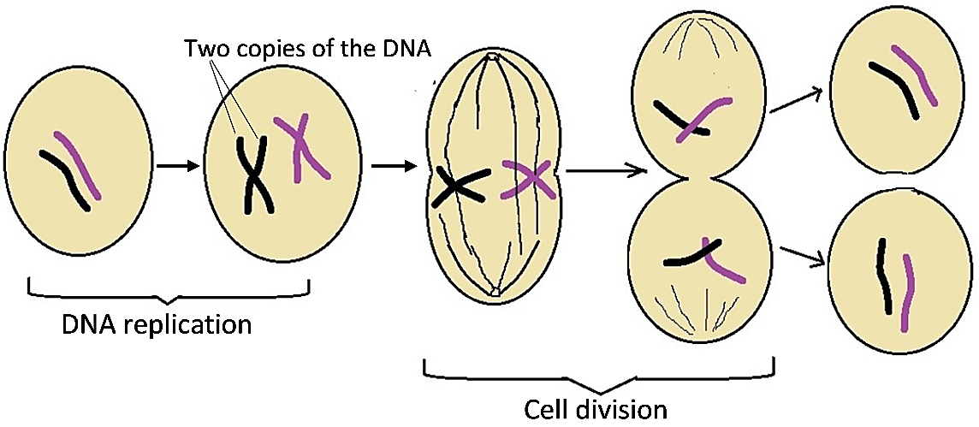

10. Explain why a cell needs to replicate its DNA before the cell divides into two daughter cells.

This figure shows how DNA replication produces two new DNA molecules that are identical to the original DNA molecule.
- First, the two strands of the DNA double helix are separated.
- Then, the base-pairing rules are used to add complementary nucleotides to form the second strand in each new DNA double helix molecule.

11a. This figure shows two free nucleotides, A and G. Which nucleotide will be added next to the top of the growing new DNA strand on the left? ___

11b. How do you know?

The top half of this figure shows a short segment of DNA. In the bottom half of the figure, the two DNA strands have been separated in preparation for replication.  12. For each of the single DNA strands, create a second DNA strand to produce two double-stranded pieces of DNA. Use the base-pairing rules to add complementary nucleotides. Your teacher will give you additional instructions.  13. Compare the two new double-stranded pieces of DNA with the original double-stranded piece of DNA. Do they all have the same sequence of nucleotides in both strands?  yes ___ no ___ | 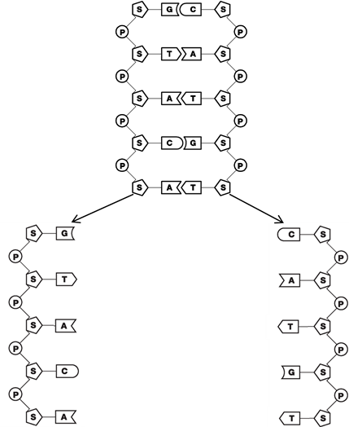

14. Why is it important for both copies of the DNA produced by DNA replication to have the exact same sequence of nucleotides as the original DNA?

Enzymes play an important role in DNA replication. For example, the enzyme DNA polymerase makes a covalent bond between each added complementary nucleotide and the previous nucleotide in a growing DNA strand. | 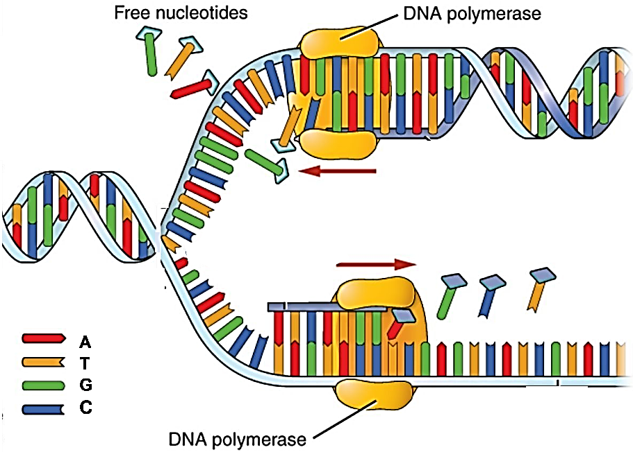

15. Based on the function of DNA polymerase, explain why each part of the name DNA polymerase (DNA, polymer, -ase) makes sense.

16a. During DNA replication, the double helix structure, the base-pairing rules, and DNA polymerase work together to make two DNA molecules that are identical to the original DNA molecule. How does the double helix structure help to produce two new DNA molecules that are identical to the original DNA molecule?

16b. How do the base-pairing rules help to produce two new DNA molecules that are identical to the original DNA molecule?

16c. Explain why DNA polymerase is needed for DNA replication.

By Dr. Ingrid Waldron, Dept Biology, Univ Pennsylvania, © 2023. This Student Handout (including a Google Docs version) and Teacher Notes (with instructional suggestions and background biology) are available at https://serendipstudio.org/exchange/bioactivities/DNA

